**Ideation Phase**

**Empathize & Discover**

|  |  |
| --- | --- |
| Date | 27 June 2025 |
| Team ID | LTVIP2025TMID21127 |
| Project Name | Sustainable Smart City Assistant |
| Maximum Marks | 4 Marks |

**Empathy Map Canvas:**

An **Empathy Map** is a simple, visual tool that helps understand the behaviors, feelings, and challenges of users. For the **Smart City AI Assistant**, it is important to understand the needs of both **citizens and city administrators** who use the tool for summarizing policies, translating information, analyzing data, and detecting city anomalies..

**Example:**

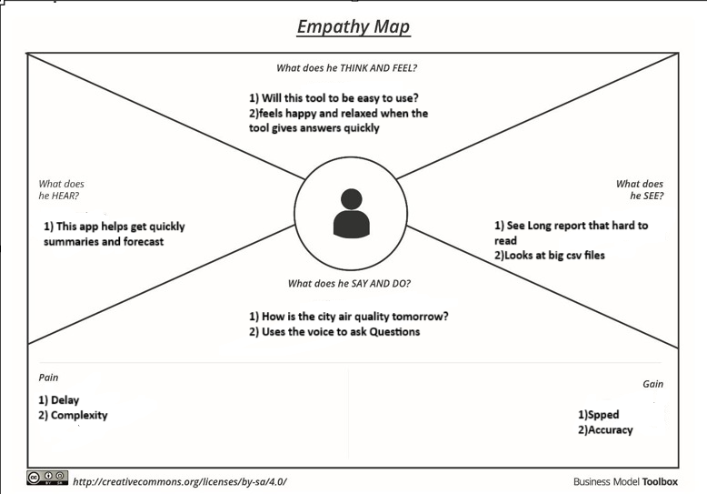

Reference: <https://www.mural.co/templates/empathy-map-canvas>

